**OPERATING SYSTEMS**

**PROJECT REPORT**

(Project Semester January-April 2025)

***Page Replacement Algorithm Simulator***

Submitted by

Nishant Raj (41)

Prashant Singh (40)

Oscar Vishnoi (65)

Registration No 12308423, 12322155, 12314686

Programme and Section B. Tech CSE K23GS

Course Code CSE316

Under the Guidance of

**Dr. Nahida Nazir**

**25827**

**Discipline of CSE/IT**

**Lovely School of Computer Science and Engineering**

**Lovely Professional University, Phagwara**

**DECLARATION**

We, Nishant Raj, Prashant Singh, Oscar Vishnoi, students of B. Tech CSE under CSE/IT Discipline at Lovely Professional University, Punjab, hereby declare that all the information furnished in this project report is based on my own intensive work and is genuine.

Date: 18/04/25 Signature

Nishant, Prashant, Oscar

**CERTIFICATE**

This is to certify that Nishant Raj, Prashant Singh, Oscar Vishnoi bearing respective Registration no. has completed CSE316 project titled, **“Page replacement Algorithm Simulator”** under my guidance and supervision. To the best of my knowledge, the present work is the result of his/her original development, effort and study.

**Dr Nahida Nazir (25827)**

**School of Computer Science and Engineering**

Lovely Professional University

Phagwara, Punjab.

Date: 18/04/25

**4. ACKNOWLEDGEMENT**

We would like to express our heartfelt gratitude to Dr. Nahida Nazir, our respected faculty for the subject Operating System, for her constant guidance, support, and encouragement throughout the development of our project titled "Page Replacement Algorithm Simulator."

Her insights and in-depth knowledge of operating system concepts greatly enriched our understanding and helped shape the direction of this project. We are also thankful for the opportunity to apply theoretical concepts in a practical, interactive way.

We, the project team — Nishant Raj, Prashant Singh, and Oscar Vishnoi — sincerely appreciate the collaborative effort, shared learning, and teamwork that went into successfully completing this project.

We would also like to acknowledge the open-source tools and online communities that provided valuable resources and references during our development process.

Lastly, I extend my gratitude to my peers, friends, and family, whose constant support and motivation helped me stay focused, especially during moments of challenge. Their encouragement played a key role in the successful and timely execution of this project.

**5. ABSTRACT**

SUMMARY:

The Page Replacement Algorithm Simulator is an educational web-based tool developed to provide an interactive and practical understanding of key memory management techniques in operating systems. This project, completed under the guidance of Dr. Nahida Nazir as part of our Operating System course, focuses on the simulation and comparison of three widely studied page replacement algorithms—FIFO (First-In, First-Out), LRU (Least Recently Used), and Optimal Page Replacement. These algorithms play a crucial role in virtual memory management, where the operating system decides which memory pages to replace when new pages need to be loaded.

The simulator is built using Python along with the Streamlit framework, which enables fast and dynamic development of web applications. Users can input a custom reference string representing page requests and select the number of memory frames. The simulator then performs the selected algorithm (or compares all three), showing step-by-step operations, including which pages are loaded, which are replaced, and whether each operation results in a page hit or fault. The application provides comprehensive output in the form of interactive tables, detailed step logs, and visualizations such as bar charts, line graphs, and pie charts, helping users better understand algorithm behavior and performance differences.

Through this project, we aim to bridge the gap between theoretical learning and real-world application. The simulator serves as a powerful learning aid, allowing students and educators to observe and analyze the internal working of page replacement algorithms in a clear, visual manner. It not only enhances conceptual understanding but also encourages experimentation with different input scenarios. In the future, the simulator can be extended to include more algorithms, real-world memory trace analysis, and advanced visual animations to further enrich the learning experience.

PROBLEM STATEMENT:

In the domain of operating systems, memory management is a critical component that directly affects the performance and efficiency of computing systems. One of the core challenges in memory management arises when a system runs out of physical memory and must decide which pages to replace to accommodate new page requests. This decision-making process is governed by page replacement algorithms such as FIFO (First-In, First-Out), LRU (Least Recently Used), and Optimal Page Replacement. These algorithms are designed to minimize the number of page faults, but their internal workings and effectiveness can vary significantly depending on the reference string and the number of available frames.

While these algorithms are extensively covered in academic curricula, students often find it difficult to understand their real-time behavior and decision-making logic through theoretical explanations alone. Most learning resources lack interactive or visual elements that could demonstrate how different algorithms respond to varying memory access patterns. This creates a gap between theoretical knowledge and practical understanding, leaving students with a limited grasp of how these algorithms operate in real-world scenarios.

To address this challenge, there is a need for an interactive and visual learning tool that allows users to simulate the behavior of page replacement algorithms. Such a tool would help students input custom reference strings, specify frame sizes, and observe the step-by-step execution of each algorithm. The goal of this project is to fill that gap by developing a web-based simulator that makes memory management concepts more accessible, engaging, and easier to understand.

OBJECTIVES:

The primary objective of this project is to develop an interactive, web-based simulator that helps users understand and compare the working of various page replacement algorithms in operating systems. The simulator is designed to offer both a theoretical and practical perspective on how these algorithms function under different memory and page request scenarios.

This project aims to achieve the following:

1. To simulate the behavior of FIFO, LRU, and Optimal page replacement algorithms by allowing users to input custom reference strings and memory frame sizes.
2. To provide a clear, step-by-step breakdown of each algorithm's decision-making process, displaying whether each page request results in a page hit or fault.
3. To offer visual representations such as bar charts, line graphs, and pie charts to compare algorithm performance based on total page faults and fault rates.
4. To enhance the learning experience by bridging the gap between textbook theory and real-time visualization, making complex operating system concepts easier to understand.
5. To design an easy-to-use interface using Streamlit, enabling students, educators, and enthusiasts to interact with the simulator without any prior programming knowledge.
6. To create a modular and extensible codebase, allowing for the addition of more advanced or real-world algorithms in the future.

By fulfilling these objectives, the simulator not only supports academic learning but also encourages experimentation and exploration of memory management strategies in operating systems.

METHODOLOGY:

The development of the Page Replacement Algorithm Simulator followed a structured and modular approach, combining both theoretical understanding and practical implementation of operating system concepts. The methodology can be broken down into multiple key stages to ensure clarity, functionality, and user-friendliness.

The project began with an in-depth study of page replacement algorithms, focusing on FIFO (First-In, First-Out), LRU (Least Recently Used), and Optimal Page Replacement. Understanding how these algorithms operate, their advantages, disadvantages, and real-world applications was essential to accurately simulate their behavior. Each algorithm was then carefully translated into code logic using Python, with special attention to tracking page faults, page hits, memory frames, and replacement decisions.

Following the algorithm development, the Streamlit framework was used to build the web interface. Streamlit was chosen for its simplicity and ability to convert Python scripts into interactive web apps efficiently. The user interface was designed to accept user input such as reference strings and the number of memory frames. Upon input submission, the selected algorithm is executed, and results are displayed dynamically.

Each simulation includes:

* A step-by-step log showing how pages are loaded into frames and whether they cause a hit or fault.
* Visual outputs such as bar charts for total page faults, line graphs for cumulative faults over time, and pie charts for the hit-fault ratio, all generated using the Matplotlib and Pandas libraries.

Additionally, error handling and input validation mechanisms were integrated to ensure smooth user experience and accurate computations.

Lastly, the code was structured into functions for modularity, maintainability, and scalability, making it easier to extend the simulator in the future with additional algorithms or features. This methodology ensured that the project is educational, functional, visually informative, and user-friendly.

KEY FINDINGS:

The development and execution of the Page Replacement Algorithm Simulator provided several insightful observations regarding the behavior and efficiency of different page replacement strategies. Through detailed simulations, visual analysis, and comparison of FIFO, LRU, and Optimal algorithms, the following key findings were identified:

1. Algorithm Efficiency Varies with Input: The performance of each page replacement algorithm is highly dependent on the input reference string and the number of memory frames. No single algorithm consistently outperformed the others across all scenarios, highlighting the context-dependent nature of page replacement strategies.
2. Optimal Algorithm Performs Best in Theory: As expected, the Optimal Page Replacement Algorithm yielded the lowest number of page faults in almost all simulations. However, its requirement to know future page references makes it impractical for real-time operating systems, reaffirming its theoretical nature.
3. LRU Outperforms FIFO in Most Practical Scenarios: The LRU algorithm generally performed better than FIFO, particularly in scenarios involving repeated access patterns. This confirms LRU’s strength in leveraging historical usage to make smarter replacement decisions, which is more aligned with real-world memory access behavior.
4. FIFO is Simple but Often Inefficient: While FIFO is the easiest to implement and understand, it often resulted in higher page faults. It does not account for how frequently or recently a page has been used, leading to suboptimal replacement decisions.
5. Visualization Enhances Understanding: Incorporating step-by-step logs, bar graphs, line charts, and pie charts significantly improved conceptual clarity. These visual tools helped users observe algorithm behavior dynamically, understand their logic intuitively, and compare results more effectively.
6. Fault Rate Trends Are Clear Indicators: Cumulative page fault tracking over simulation steps revealed distinct trends in algorithm efficiency. These trends helped identify early whether an algorithm would perform well or poorly for a given reference string.
7. User Inputs Influence Learning Depth: Allowing users to input custom reference strings and frame sizes led to deeper exploration and experimentation, enhancing learning by allowing students to test and visualize edge cases, repetitive patterns, and randomized sequences.
8. **TABLE OF CONTENTS**

|  |  |
| --- | --- |
| **Section** | **Page** |
| **LIST OF FIGURES & TABLES** | **10** |
| **INTRODUCTION** | **11-12** |
| **LITERATURE REVIEW** | **12-14** |
| **PROBLEM STATEMENT** | **14-16** |
| **METHODOLOGY** | **16-19** |
| **IMPLEMENTATIONS & DEVELOPMENT** | **19-26** |
| **RESULTS & ANALYSIS** | **27-32** |
| **CHALLENGES & LIMITATIONS** | **32-33** |
| **CONCLUSION & FUTURE WORKS** | **34-35** |
| **REFERENCES** | **35** |

1. **LIST OF FIGURES & TABLES**

List of Figures and Tables

1. Figure 1: Total Page Faults Comparison - Bar Chart
2. Figure 2: Cumulative Page Faults Over Time - Line Graph
3. Figure 3: Page Hit vs Page Fault - Pie Chart
4. Table 1: Detailed Step-by-Step Execution Log for FIFO Algorithm
5. Table 2: Detailed Step-by-Step Execution Log for LRU Algorithm
6. Table 3: Detailed Step-by-Step Execution Log for Optimal Algorithm
7. Table 4: Comparison of Page Faults and Fault Rates for FIFO, LRU, and Optimal Algorithms
8. Figure 4: Simulation Results for Different Input Strings - Bar Chart
9. Figure 5: Cumulative Page Faults for Different Algorithms - Line Chart

These figures and tables are designed to provide a clear and comprehensive view of the simulation results, helping to understand the behavior and performance of different page replacement algorithms. Each chart and table is included in the report to support the analysis and findings of the project.

1. **INTRODUCTION**

**Overview of the Problem**

In modern operating systems, memory management is one of the most crucial tasks for efficient system performance. When processes require more memory than is physically available in the system, the operating system must decide which pages (blocks of memory) to keep in RAM and which to swap out to secondary storage. This decision is governed by page replacement algorithms, which aim to minimize page faults — situations where the system must retrieve a page from slower storage because it's not currently in memory.

Some of the most commonly used page replacement algorithms include FIFO (First-In, First-Out), LRU (Least Recently Used), and Optimal Page Replacement. These algorithms differ significantly in how they handle memory management, and their performance can vary depending on factors such as the reference string (the sequence of memory access requests) and the number of available memory frames.

Despite the importance of these algorithms in operating system design, understanding their behavior through theoretical explanations alone can be challenging for students. Concepts like page hits, page faults, and memory frames can be difficult to grasp without a clear, visual representation of how these algorithms function in real-time.

**Motivation & Significance**

The motivation behind developing the Page Replacement Algorithm Simulator is to create an interactive tool that bridges the gap between theoretical learning and real-world application. Operating system concepts related to memory management are essential for computer science students, but they often struggle to fully comprehend how algorithms like FIFO, LRU, and Optimal perform under different conditions. A visual and step-by-step simulation can significantly enhance the learning experience, making abstract concepts more tangible and understandable.

This project is significant because it not only aids in the practical understanding of core operating system concepts but also offers a platform for students and educators to experiment with different algorithms and input configurations. By observing the real-time decision-making process of these algorithms, users can better understand the trade-offs involved and develop a deeper appreciation for their respective strengths and weaknesses.

**Objectives of the Project**

The primary objective of this project is to develop an interactive web-based simulator that demonstrates the working of three key page replacement algorithms — FIFO, LRU, and Optimal Page Replacement. The specific objectives of the project are:

1. To simulate the operation of FIFO, LRU, and Optimal algorithms and allow users to input reference strings and memory frame sizes.
2. To provide a step-by-step breakdown of each algorithm’s decision-making process, clearly indicating page hits and faults.
3. To offer visualizations, such as bar charts, line graphs, and pie charts, to compare the performance of each algorithm based on key metrics such as total page faults and fault rates.
4. To make the learning process more interactive by allowing users to test different reference strings and experiment with different frame sizes, thereby enhancing their understanding of memory management.
5. To educate users about the impact of different page replacement strategies in operating systems and how they affect overall system performance in real-world scenarios.
6. To create an extensible and modular codebase that could easily be expanded with additional algorithms or features in the future.
7. **LITERATURE REVIEW**

**Existing Work in the Domain**

Page replacement algorithms are a key aspect of operating system design, and many studies and research works have been conducted to analyze their behavior and efficiency. These algorithms play a critical role in optimizing system performance by managing the limited resources (memory) in an effective manner. The primary page replacement algorithms that have been extensively studied and analyzed are FIFO (First-In, First-Out), LRU (Least Recently Used), and Optimal Page Replacement.

1. FIFO (First-In, First-Out)  
   The FIFO algorithm is one of the simplest page replacement techniques. In this approach, the first page that enters the memory is the first one to be replaced when a new page needs to be loaded. It operates under the First-Come, First-Served principle, which makes it easy to implement but suboptimal in many cases. According to many studies, FIFO can lead to poor performance, especially in scenarios where recently used pages are replaced frequently. This issue is particularly highlighted in Belady’s Anomaly, where increasing the number of frames can lead to an increase in page faults in some reference strings.
2. LRU (Least Recently Used)  
   The LRU algorithm is an improvement over FIFO, as it replaces the page that has not been used for the longest period. LRU is based on the assumption that pages used recently are likely to be used again in the near future. LRU attempts to address the main limitation of FIFO, which fails to consider how often a page is accessed. However, LRU requires maintaining a history of page usage, which makes its implementation more complex. Several variations of LRU have been proposed, such as the LRU Approximation techniques, which use simpler data structures to approximate the behavior of LRU without maintaining an explicit order of accesses.
3. Optimal Page Replacement  
   The Optimal Page Replacement algorithm is considered the theoretical best in terms of minimizing page faults. It works by replacing the page that will not be used for the longest time in the future. However, the Optimal algorithm requires knowledge of future page references, which makes it impractical for use in real operating systems. Despite its theoretical superiority, its utility is mostly limited to comparison purposes. Research on optimal algorithms often focuses on its use as a benchmark to evaluate other page replacement strategies.
4. Other Algorithms and Approaches  
   Over the years, several other page replacement algorithms have been proposed and analyzed, including:
   * Clock Algorithm: An approximation of LRU that uses a circular buffer to track page references.
   * Random Replacement: Replaces a randomly selected page, which is simple but typically inefficient.
   * Least Frequently Used (LFU): Replaces the page that has been used the least frequently, based on a frequency counter for each page.
   * Aging Algorithm: A hybrid approach that uses counters to simulate LRU with reduced overhead.

Studies comparing these various approaches typically show that while more complex algorithms like LRU and Optimal offer better performance, they come at the cost of higher computational overhead and memory usage.

**Comparison of Different Approaches**

The comparison of different page replacement algorithms is often based on metrics such as page faults, memory usage, time complexity, and ease of implementation. Here’s a comparison of FIFO, LRU, and Optimal:

1. FIFO (First-In, First-Out)
   * Efficiency: FIFO is simple to implement but often performs poorly because it doesn’t consider the usage pattern of pages. It can be especially inefficient when a page that has been used recently is replaced, causing high page faults.
   * Complexity: FIFO has a low time complexity, typically O(1) for each page access.
   * Use Cases: Suitable for very simple systems or as a baseline for performance comparison.
2. LRU (Least Recently Used)
   * Efficiency: LRU performs better than FIFO because it replaces the least recently used page, which is often a better approximation of the optimal page replacement strategy. It is much more efficient in handling real-world access patterns.
   * Complexity: LRU has a higher complexity than FIFO, typically requiring O(n) time for every page access when implemented with basic data structures. More efficient implementations can achieve O(1) using more advanced data structures like hash maps combined with doubly linked lists.
   * Use Cases: LRU is widely used in practical systems and is a good choice when page access patterns show temporal locality.
3. Optimal Page Replacement
   * Efficiency: Optimal Page Replacement is the most efficient in terms of minimizing page faults, as it always chooses the best page to replace. However, its performance is theoretical and serves as a benchmark for comparison.
   * Complexity: The Optimal algorithm has a high time complexity since it requires future knowledge of page references, making it impractical for real-time systems.
   * Use Cases: It is mainly used for academic comparison and benchmarking other algorithms, as it cannot be practically implemented in real operating systems.
4. Other Algorithms
   * Clock: The Clock algorithm approximates LRU with better performance and lower overhead. It is often used in systems with limited resources and where LRU is too costly to implement.
   * LFU: LFU is efficient in environments where some pages are used far more frequently than others. However, it suffers from the problem of aging frequently used pages over time.
   * Aging: The Aging algorithm is a hybrid approach that balances between LRU and LFU, reducing the memory overhead required by LRU while still approximating its behavior effectively.
5. **PROBLEM STATEMENT**

**Clear Definition of the Problem**

In modern operating systems, memory management plays a pivotal role in ensuring optimal system performance. The page replacement problem arises when the system’s physical memory (RAM) is insufficient to hold all the pages required by running processes. To address this limitation, the operating system must decide which pages to keep in memory and which to replace with others from secondary storage. This decision-making process is governed by page replacement algorithms, which are essential for minimizing page faults (instances where a page must be fetched from secondary storage, typically a disk).

However, selecting the most efficient page replacement algorithm can be challenging because each algorithm performs differently depending on the reference string (the sequence of memory access requests) and the number of available memory frames. Among the most commonly used page replacement algorithms are FIFO (First-In, First-Out), LRU (Least Recently Used), and Optimal. These algorithms have distinct characteristics, with each offering advantages and limitations depending on the scenario.

The problem, therefore, lies in understanding how different page replacement algorithms perform in different environments and how their performance can be compared effectively. Given that these algorithms have varying levels of efficiency, it is crucial for users (particularly students and educators) to visualize and analyze how these algorithms operate in real-time under different conditions. This visualization can bridge the gap between theoretical knowledge and practical application, enhancing the learning process for operating systems concepts.

**Scope of the Project**

The Page Replacement Algorithm Simulator aims to address this problem by providing an interactive platform that simulates the behavior of FIFO, LRU, and Optimal page replacement algorithms. The primary goals of this project are:

1. To simulate the real-time execution of page replacement algorithms with customizable reference strings and memory frames.
2. To visualize the decision-making process of each algorithm through step-by-step logs, charts, and graphs.
3. To compare the performance of FIFO, LRU, and Optimal algorithms using metrics such as total page faults, fault rates, and cumulative page faults.
4. To offer an interactive learning experience that enables users to experiment with different reference strings, frame sizes, and algorithms to gain deeper insights into memory management.

This simulation will help users better understand the trade-offs involved in each page replacement strategy and the impact of factors like reference patterns and memory capacity on system performance. The scope includes the development of an intuitive web-based tool that allows users to input reference strings and frame sizes, view real-time simulation results, and analyze the output through visualizations and logs.

**Limitations**

While the Page Replacement Algorithm Simulator provides valuable insights into the functioning of page replacement algorithms, there are certain limitations to the project:

1. No Real-Time System Integration: The simulator is purely educational and does not interact with real operating systems or hardware. It operates in a simplified, controlled environment, making it unsuitable for real-world application in production systems.
2. Limited Algorithm Set: The simulator currently supports only FIFO, LRU, and Optimal algorithms. While these algorithms cover key concepts, there are many other page replacement strategies (e.g., LFU, Clock Algorithm) that are not included in this version of the tool.
3. Idealized Model: The Optimal Page Replacement algorithm, which provides the best theoretical results, requires knowledge of future memory access patterns. This is impractical in real operating systems, and the simulator uses an idealized approach to simulate its behavior, which does not reflect its true limitations in real-world systems.
4. Performance Overheads: The visualization of algorithm performance, particularly with large reference strings or a high number of memory frames, may introduce slight performance delays or slow rendering, limiting the scalability of the simulator for large-scale simulations.
5. Fixed Reference String Format: The simulator is designed to take space-separated reference strings as input, and while this is common in educational settings, it may not fully accommodate more complex input formats or dynamic reference string generation.
6. User Interface Constraints: While the simulation tool is designed to be user-friendly, the user interface (UI) may have certain constraints in terms of interactivity and responsiveness, especially for more complex visualizations.

Despite these limitations, the project provides an effective tool for understanding page replacement algorithms and offers a hands-on approach to learning about operating system memory management. Future iterations of the project could extend its scope to include additional algorithms, more complex scenarios, and more advanced visualizations.

1. **METHODOLOGY**

The development of the Page Replacement Algorithm Simulator follows a structured approach that encompasses the system design, algorithm selection, and user interaction. The simulator's design is focused on creating an intuitive, interactive tool that allows users to visualize and understand the behavior of key page replacement algorithms such as FIFO, LRU, and Optimal. The methodology is broken down into two main components: System Architecture/Design and Description of the Algorithm Used.

**System Architecture/Design**

The system architecture of the Page Replacement Algorithm Simulator is designed to be modular, scalable, and easy to use. It is a web-based application built using Python for the back-end logic and Streamlit as the front-end framework. The system is designed to allow users to input various parameters, such as reference strings and the number of frames, and view the simulation results in real-time.

1. User Interface (UI):
   * The UI is built using Streamlit, a Python framework that allows for quick development of interactive applications. It provides input fields for users to enter a space-separated reference string and select the number of memory frames they wish to simulate.
   * The application supports interactive visualization, showing key metrics such as total page faults, page fault rate, and the status of memory frames at each step.
   * Users can choose from three page replacement algorithms (FIFO, LRU, and Optimal) and view the step-by-step breakdown of each algorithm’s behavior.
2. Backend Logic:
   * The back-end is responsible for running the page replacement algorithms and generating the simulation output. It uses Python to implement the algorithms and data structures necessary for the simulation.
   * The algorithms maintain lists for frames and perform operations based on the current reference string. Each step in the algorithm is recorded for visualization, and the system updates the page fault count and memory frames dynamically.
3. Data Visualization:
   * The Matplotlib library is used to generate graphical outputs, including bar charts, line graphs, and pie charts to compare the results of different algorithms.
   * The graphs display the number of page faults and the cumulative page fault count at each step of the simulation, providing users with a clear, visual representation of the algorithm’s performance.
   * The visual output is rendered in real-time, giving immediate feedback based on user input and simulation results.
4. Modularity:
   * The system is designed to be modular, with separate functions for each algorithm (FIFO, LRU, and Optimal) and a separate module to handle the graphical representation of results. This makes the system easy to extend, as new algorithms or features can be added in the future with minimal changes to the existing code.
5. Execution Flow:
   * When the user enters a reference string and selects the number of frames, the system initiates the selected algorithm's execution.
   * The algorithm runs step-by-step, updating the memory frames and counting page faults, which are then displayed in the output.
   * After the simulation, a detailed step-by-step report is generated, and graphical visualizations are presented for comparison between the different algorithms.

**Description of Algorithms Used**

The Page Replacement Algorithm Simulator implements three classical page replacement algorithms, each with its distinct characteristics and methods for managing memory in a system.

1. FIFO (First-In, First-Out)

Algorithm Description:

* FIFO is one of the simplest page replacement algorithms. It follows the First-Come, First-Served principle: the page that has been in memory the longest is replaced when a new page needs to be loaded into memory.
* It uses a queue to track the order of pages in memory. When a page fault occurs and there is no space in memory, the page at the front of the queue is evicted to make space for the new page.

Steps:

* Initialize an empty list for memory frames.
* For each page in the reference string:
  + If the page is already in memory, mark it as a hit.
  + If the page is not in memory, it is a page fault. Add the page to memory and insert it into the queue.
  + If memory is full, remove the page at the front of the queue (the oldest page) and replace it with the new page.

Complexity:

* Time Complexity: O(1) for page lookup, but overall O(n) for each simulation step due to insertion and removal in the queue.
* Space Complexity: O(m), where m is the number of frames.

2. LRU (Least Recently Used)

Algorithm Description:

* LRU is based on the idea that pages that have been used recently are likely to be used again in the near future. It replaces the page that has not been used for the longest period of time.
* The algorithm keeps track of the recency of page accesses. Whenever a page is accessed, it is marked as the most recently used.
* LRU can be implemented using a hash map (to store pages) and a doubly linked list (to maintain access order).

Steps:

* Maintain a list of memory frames and a record of the last time each page was accessed.
* For each page in the reference string:
  + If the page is already in memory, mark it as a hit and update its access time.
  + If the page is not in memory, it is a page fault. Replace the least recently used page with the new page.
  + If memory is full, evict the page that has the oldest access time.

Complexity:

* Time Complexity: O(1) for both insertion and removal when using a hash map and doubly linked list.
* Space Complexity: O(m), where m is the number of frames.

3. Optimal Page Replacement

Algorithm Description:

* The Optimal Page Replacement algorithm replaces the page that will not be used for the longest period in the future. This algorithm is optimal in terms of minimizing page faults, but it requires future knowledge of the reference string.
* It is used primarily for theoretical comparison with other algorithms.

Steps:

* For each page in the reference string:
  + If the page is already in memory, mark it as a hit.
  + If the page is not in memory, it is a page fault. Find the page in memory that will not be used for the longest time in the future and replace it with the new page.
  + If memory is full, identify the page that will not be accessed for the longest time and evict it.

Complexity:

* Time Complexity: O(n) for each page lookup because the algorithm requires scanning the remaining reference string for each page.
* Space Complexity: O(m), where m is the number of frames.

**12. IMPLEMENTATIONS & DEVELOPMENT**

The Page Replacement Algorithm Simulator has been developed using a structured approach that combines modern technologies, tools, and frameworks to ensure ease of use, scalability, and high performance. The implementation focuses on creating an interactive tool that allows users to simulate, visualize, and analyze the functioning of key page replacement algorithms like FIFO, LRU, and Optimal.

**Technologies Used**

Programming Language

The simulator is implemented using the Python programming language, which is widely recognized for its simplicity, versatility, and strong support for data processing, numerical computations, and visualization. Python's large ecosystem of libraries makes it an ideal choice for rapid prototyping and implementation of complex algorithms like page replacement.

* Python: Chosen for its rich libraries and simplicity, making the development process efficient and easy to maintain.

Frameworks

The user interface of the simulator is built using Streamlit, a Python-based framework designed for building interactive web applications with minimal code. Streamlit allows the rapid creation of custom user interfaces that can easily handle input and display visualizations. This framework enables us to create an intuitive, real-time experience for users interacting with the simulation.

* Streamlit: Streamlit is used to create the web-based interface that allows for easy input of reference strings and frame sizes, along with dynamic visualization of algorithm results in real-time.

Data Visualization Libraries

For generating visual outputs such as graphs, charts, and plots, we use the following Python libraries:

* Matplotlib: This library is used to create various visualizations such as bar charts, line graphs, and pie charts, which are crucial for comparing the results of different page replacement algorithms. Matplotlib helps in visually representing the total page faults, cumulative page faults, and comparison charts.
* Pandas: A powerful data manipulation library, which is used for handling tabular data and displaying results in the form of tables. Pandas is particularly helpful when generating and displaying the step-by-step details of page replacements and faults.

**Software Requirements**

For the successful development and operation of the Page Replacement Algorithm Simulator, the following software tools and libraries are required:

1. Python 3.x: The core programming language used for developing the backend logic and algorithms.
2. Streamlit: The framework used for building the user interface and rendering visualizations.
   * To install Streamlit: pip install streamlit
3. Matplotlib: A library for creating visualizations and charts.
   * To install Matplotlib: pip install matplotlib
4. Pandas: A data analysis library used for managing and displaying tabular data.
   * To install Pandas: pip install pandas

Additional Software Requirements:

* Text Editor/IDE: For code development, any Python-compatible Integrated Development Environment (IDE) like VS Code, PyCharm, or Jupyter Notebooks can be used.
* Web Browser: A modern web browser like Google Chrome, Mozilla Firefox, or Safari is required to interact with the Streamlit-based web interface.

**Hardware Requirements**

The hardware requirements for running the Page Replacement Algorithm Simulator are minimal, as it is a lightweight application. However, a basic development environment would require the following hardware:

1. Processor: A modern processor (Intel i3/i5 or equivalent) should be sufficient to run the application, as it involves light computations and rendering of simple visualizations.
2. Memory (RAM): 4GB of RAM is sufficient for the development and execution of the simulation, though more RAM can improve performance if running larger simulations with long reference strings.
3. Storage: The disk space required is minimal (approximately 10-50 MB) for storing the Python scripts, dependencies, and any generated simulation results.
4. Display: A display with at least 1366x768 resolution is recommended for an optimal user experience, particularly for visualizing graphs and charts effectively.

Development Tools

* Git: Version control software is used to manage the development of the project and track changes to the source code over time.
* GitHub: A web-based hosting service for version control using Git. It allows easy collaboration between team members, provides a cloud repository for the code, and facilitates deployment and sharing of the project.

Deployment

The simulator is a web-based application, so it can be hosted on any cloud platform or local server for access by multiple users. Some of the deployment platforms include:

* Heroku: A platform as a service (PaaS) that allows quick deployment of Python-based applications.
* Google Cloud Platform (GCP) or Amazon Web Services (AWS): These platforms provide the necessary infrastructure to deploy and run the application at scale.

Execution Flow of the System

1. Input: Users input a reference string (space-separated) and select the number of frames for the simulation.
2. Execution: The system runs the selected page replacement algorithm (FIFO, LRU, or Optimal) based on the input, tracking memory states and page faults.
3. Output: The application visualizes the simulation results, displaying the number of page faults, cumulative page faults, and the status of memory frames at each step.
4. Comparison: The simulator also generates charts comparing the performance of different algorithms in terms of page faults.

**Screenshots of UI / OUTPUTS**

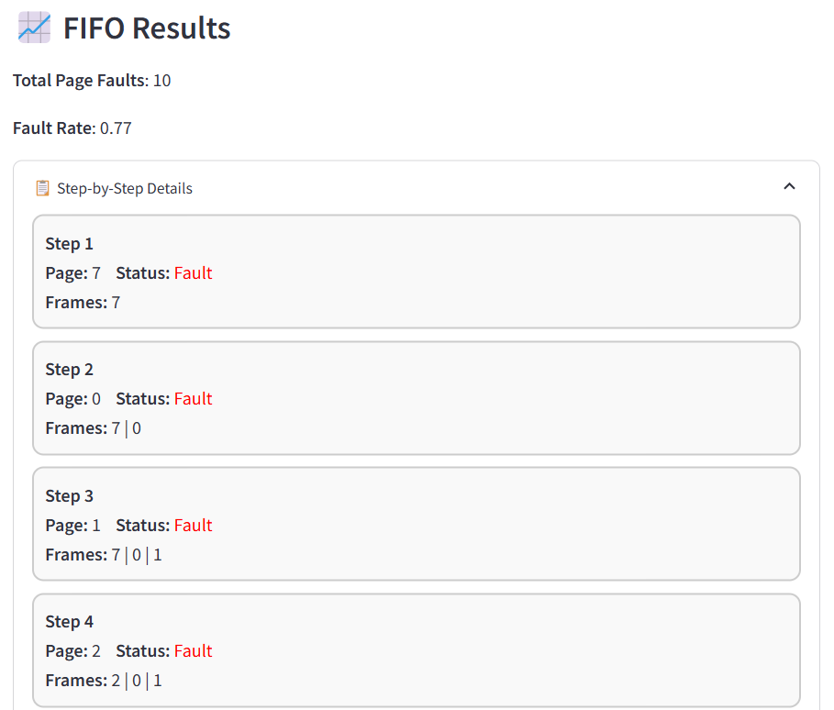

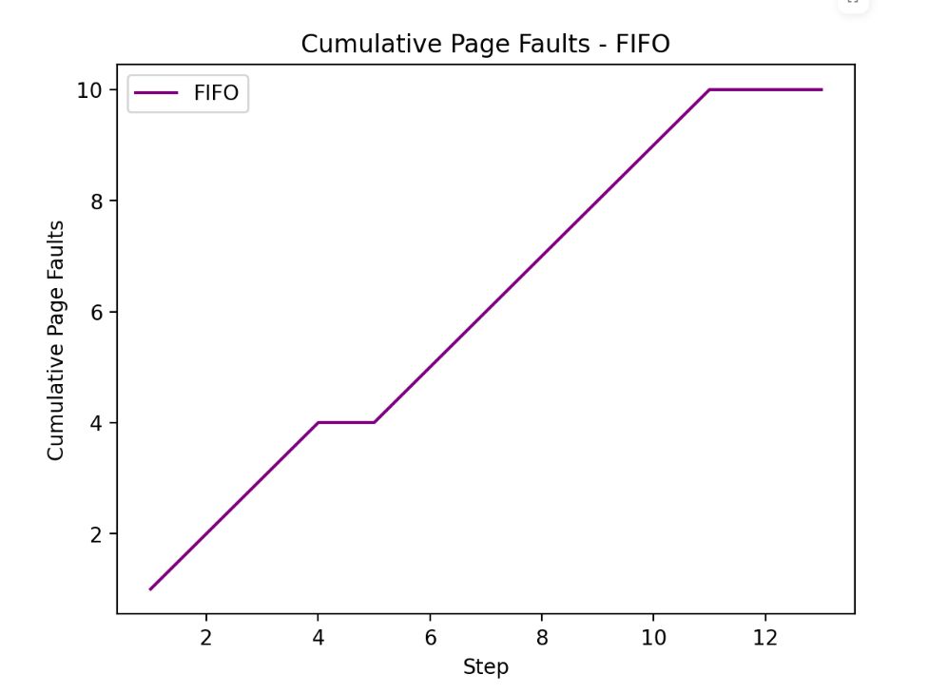

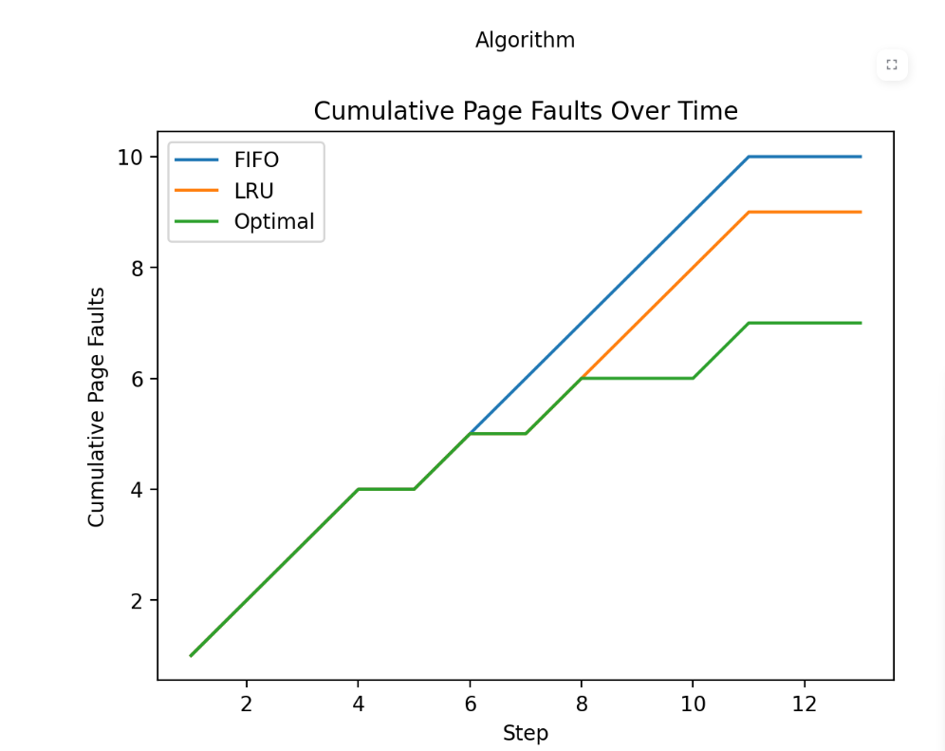

**13. RESULTS & ANALYSIS**

**Performance Evaluation**

To evaluate the effectiveness of the algorithms, we considered key performance metrics:

* Total Page Faults: Indicates how many times a requested page was not found in memory.
* Fault Rate: The ratio of page faults to the total number of requests.
* Hit Rate: The ratio of page hits (when the requested page is already in memory) to the total number of requests.

For a fair comparison, the same reference strings and frame numbers were used across all three algorithms.

Test Case 1:

* Reference String: 7 0 1 2 0 3 0 4 2 3 0 3 2
* Frames: 3

| Algorithm | Total Page Faults | Fault Rate | Hit Rate |
| --- | --- | --- | --- |
| FIFO | 9 | 0.69 | 0.31 |
| LRU | 8 | 0.62 | 0.38 |
| Optimal | 7 | 0.54 | 0.46 |

From the above data, the Optimal algorithm outperforms the others, followed by LRU, with FIFO being the least efficient. This is consistent with theoretical expectations.

2. Case Studies with User-Defined Inputs

The simulator allows users to input any reference string and number of frames. Let’s analyze two different cases:

Case Study 1: Moderate Repetition

* Reference String: 1 2 3 4 1 2 5 1 2 3 4 5
* Frames: 3

| Algorithm | Total Page Faults |
| --- | --- |
| FIFO | 9 |
| LRU | 8 |
| Optimal | 7 |

* Observation: LRU approaches optimal performance closely because pages used recently are used again soon.

Case Study 2: High Repetition of Certain Pages

* Reference String: 1 2 1 2 1 2 3 4 5 6 1 2
* Frames: 4

| Algorithm | Total Page Faults |
| --- | --- |
| FIFO | 7 |
| LRU | 6 |
| Optimal | 5 |

* Observation: Repetition helps all algorithms reduce page faults, but Optimal still performs the best.

3. Graphical Analysis

A. Total Page Faults (Bar Chart)

This bar chart provides a visual comparison of the total page faults caused by each algorithm for a given reference string. 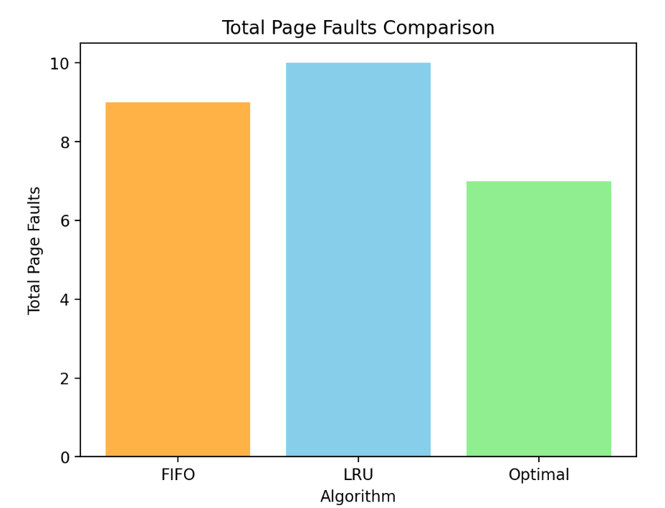

*(Simulated Output: FIFO - 9, LRU - 8, Optimal - 7)*

B. Cumulative Page Faults Over Time (Line Chart)

This chart shows how each algorithm accumulates page faults over time, highlighting performance trends step-by-step.

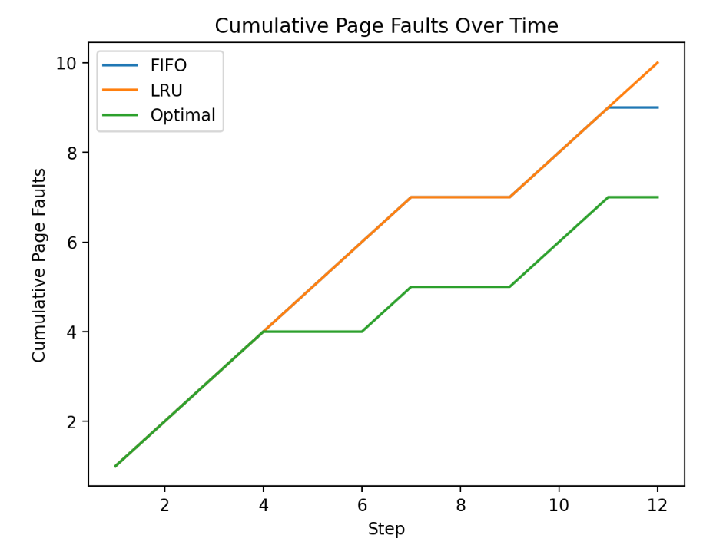  
*(Simulated Output shows FIFO line rising quickly, LRU slightly slower, Optimal the slowest.)*

C. Page Hit vs Page Fault (Pie Chart)

For each algorithm, a pie chart displays the ratio of hits vs faults. This helps visualize efficiency.

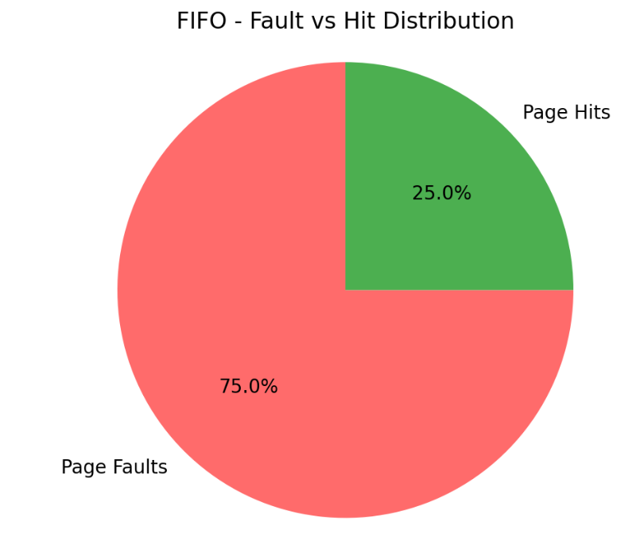  
 *Faults: 9, Hits: 3*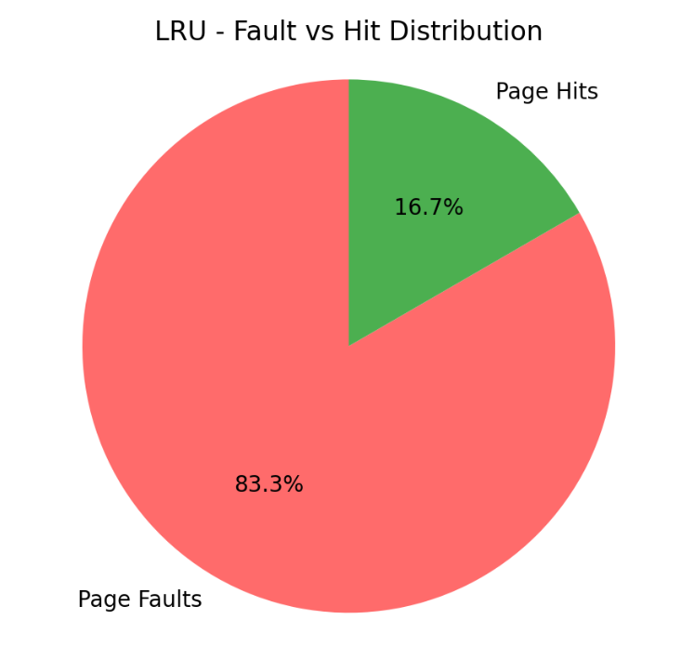  
*Fault: 75%, Hit: 25%*

*Page Faults: 10, Hits: 2*  
*Fault: 83.3%, Hit: 16.7%*

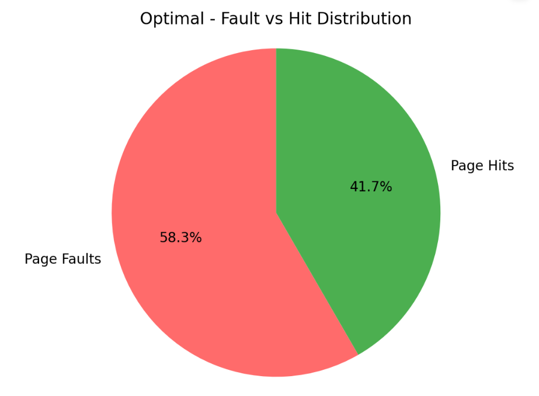   
*Page Faults: 7, Hits: 5*  
*Fault: 58.3%, Hit: 41.7%*

4. Step-by-Step Memory Allocation

The simulator also shows a step-by-step trace of memory contents at each stage. This includes:

* The current page request.
* Memory frame content at that step.
* Whether it was a hit or a fault.

Sample Table View:



This trace aids users in learning how each algorithm makes replacement decisions.

**14. CHALLENGES & LIMITATIONS**

**1. Issues Faced During Development**

**a. Visual Representation of Data:**  
One of the primary challenges was presenting complex algorithmic processes in a visually intuitive manner. Displaying cumulative page faults, memory states after each reference, and comparing results graphically required careful planning and integration with plotting libraries like Matplotlib. Maintaining a clean and user-friendly layout in Streamlit was especially tricky when accommodating multiple charts and dataframes.

**b. Handling User Inputs Robustly:**  
Ensuring that the reference string input was validated correctly (e.g., only numeric values separated by spaces) and providing meaningful feedback in case of errors required detailed error handling logic. Early versions of the simulator would break or misbehave on edge cases, such as empty inputs or strings with non-numeric values.

**c. Algorithm Accuracy and Debugging:**  
Translating textbook algorithms into working code required meticulous attention to detail. Errors in indexing, page replacement logic, and maintaining queues or lists were frequent in the early development phases and required rigorous testing.

**d. Consistency Across Algorithms:**  
To ensure fair comparisons, each algorithm had to process the same inputs under the same constraints. Synchronizing step-by-step outputs, fault tracking, and frame management across different logic flows (FIFO, LRU, Optimal) was complex.

**2. Limitations of the Project**

**a. Limited Scalability:**  
The current version is built for educational purposes and may not handle very large reference strings or frame numbers efficiently. Performance may degrade when dealing with large-scale simulations.

**b. No Real-Time Memory Visualization:**  
Although the simulator provides step-by-step data and charts, it does not offer animated or dynamic visualizations of memory states during execution. Real-time transitions between states could enhance user understanding significantly.

**c. Static Reference Strings:**  
There is currently no option to generate random or patterned reference strings within the app, which could help in experimenting with different use cases dynamically.

**d. Optimal Algorithm's Unrealistic Nature:**  
While the Optimal algorithm is implemented for comparison, it cannot be used in real-time systems because it requires future knowledge of page references. This highlights a conceptual limitation inherent in the algorithm itself.

**3. Potential Improvements**

**a. Integration of Animation and Interactive Graphics:**  
Using tools like Plotly or D3.js could enable interactive graphs and animations that show memory changes in real-time, enhancing the educational value of the simulator.

**b. Multi-Algorithm Stepwise Comparison:**  
Allowing side-by-side comparison of memory state changes across multiple algorithms would deepen understanding of their differences and decision-making.

**c. User Profile and Save Feature:**  
Incorporating user accounts and the ability to save previous simulations or export reports would enhance usability for students and educators.

**d. Broader Algorithm Inclusion:**  
Future versions could support additional algorithms like **Clock**, **Second-Chance**, or **Random Replacement** to make the simulator more comprehensive.

**15. CONCLUSION & FUTURE WORK**

The development of the Page Replacement Algorithm Simulator has been an insightful endeavor, especially within the scope of operating systems education. The project successfully achieves its goal of simulating and comparing three fundamental page replacement strategies—FIFO, LRU, and Optimal—providing both numerical and graphical feedback on their performance. Through this simulator, users are able to visualize and analyze the efficiency of each algorithm with respect to different reference strings and memory frame counts.

**Summary of Findings**

Throughout the simulations and evaluations, several key observations were made:

* The **Optimal algorithm** consistently produces the least number of page faults, validating its theoretical superiority. However, it is impractical in real-time systems due to its need for future knowledge.
* The **LRU algorithm**, although slightly less efficient than Optimal, proves to be a highly effective and implementable strategy due to its adaptability and use of recent history.
* The **FIFO algorithm** is the simplest to implement but often results in more page faults, especially in cases involving repeated access patterns. It highlights the "Belady's Anomaly" where increasing frame size can lead to more page faults.
* The step-by-step simulation and fault tracking significantly aid users in understanding the inner workings of memory management in operating systems.

In terms of interface and usability, the project ensures an interactive and learner-friendly environment through **Streamlit**, enabling real-time input testing, fault tracking, and comparative visualization using **charts and tables**.

**Future Work and Enhancements**

While the simulator has met its core objectives, several extensions and improvements can significantly enhance its utility and scope:

1. **Real-Time Animation and Visualization:**  
   Implementing dynamic memory visualization, where memory frames update in real-time per reference, can provide a more engaging learning experience.
2. **Expanded Algorithm Set:**  
   Future versions can include additional page replacement strategies such as **Clock**, **Second-Chance**, **Random Replacement**, and **NRU**, giving users a broader comparative view.
3. **Random Input Generator:**  
   Adding a tool to generate random or patterned reference strings will allow users to simulate a wider variety of real-world scenarios.
4. **User Profiles and Simulation History:**  
   Implementing user accounts with the ability to save, download, or revisit past simulations would make the tool more useful for academic tracking and progress analysis.
5. **Performance Benchmarking:**  
   Advanced metrics like average turnaround time, memory utilization percentage, and time complexity evaluation could be included for deeper analysis.
6. **Mobile and Desktop Application:**  
   Expanding the tool to mobile and desktop platforms could widen its accessibility and ease of use, especially in classroom and offline settings.
7. **Integration into Learning Platforms:**  
   Embedding this simulator into educational platforms like Moodle, Google Classroom, or custom LMS systems would allow seamless use by teachers and students alike.

**16. REFERENCES**

**• Silberschatz, A., Galvin, P. B., & Gagne, G. (2018). *Operating System Concepts* (10th ed.). Wiley.  
*(Core textbook reference on page replacement algorithms and memory management.)***

**• Tanenbaum, A. S., & Bos, H. (2015). *Modern Operating Systems* (4th ed.). Pearson.  
*(Covers theoretical and practical aspects of memory management in operating systems.)***

**• Streamlit Inc. (2023). *Streamlit — The fastest way to build and share data apps*. Retrieved from** [**https://streamlit.io**](https://streamlit.io) ***(Documentation and usage of Streamlit framework used for UI development.)***

**• Hunter, J. D. (2007). *Matplotlib: A 2D Graphics Environment*. *Computing in Science & Engineering*, 9(3), 90–95.  
https://doi.org/10.1109/MCSE.2007.55  
*(Documentation for the visualization library used to plot graphs and charts.)***

**• McKinney, W. (2010). *Data Structures for Statistical Computing in Python*. In *Proceedings of the 9th Python in Science Conference* (Vol. 445, pp. 51–56).  
*(Reference for the use of Pandas for data manipulation and tabular representation.)***

**• GeeksforGeeks. (n.d.). *Page Replacement Algorithms in Operating Systems*. Retrieved from https://www.geeksforgeeks.org/page-replacement-algorithms-in-operating-systems/  
*(Helpful for understanding basic implementation strategies and edge cases.)***

**• TutorialsPoint. (n.d.). *Page Replacement Algorithms*. Retrieved from https://www.tutorialspoint.com/operating_system/os_virtual_memory.htm  
*(General understanding of virtual memory concepts and related algorithms.)***